Clicking on any of these pictures will take you to our web site!

David Rudkin, as the Young Vic revival of Afore Night Come proved, is one of our theatre's most idiosyncratic voices. His latest play, a two-man creation myth presented by the touring AJTC company, is a weirdly compelling affair: a mix of spiritual exploration, linguistic experiment and artistic metaphor.

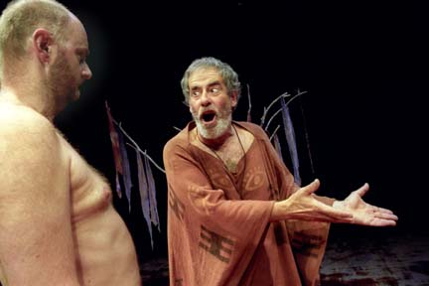
We are on an island where a powerful shamanist creates a giant figure called Adamu out of clay. Having taught his creature the rudiments of language and civility, the magician uses him as an instrument of revenge against an oppressive neighbouring tribe. Having once tasted blood, however, Adamu can sate his violent appetite only by devouring an enemy child. Reluctantly, the shaman decides he must unmake his monster - only to find that what is created cannot easily be destroyed.

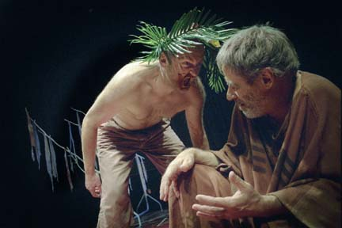
Clearly, Rudkin has shopped around among the world's myths: echoes of Genesis, The Tempest and Mary Shelley's Frankenstein abound. William Golding's The Inheritors also comes to mind in the creator's attempt to teach his creature language, which leads to an amusing role reversal when Adamu gives peremptory orders to his godhead.
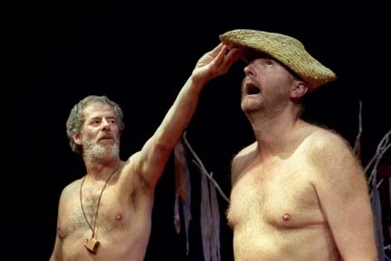
Rudkin's larger point seems to be that mankind must take responsibility for its violence and cruelty without hiding behind convenient theistic alibis. It is a potent argument at a time when east and west both invoke their respective gods to justify war. Locked into the play is also a cryptic message about art's capacity to elude its creator.

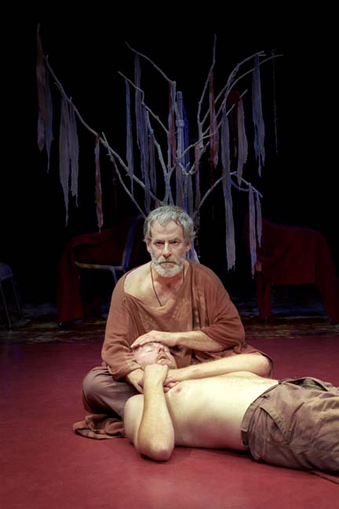
Whatever its ultimate meaning, the play is certainly like nothing else currently on show. It is authoritatively played by Iain Armstrong, as the grizzled, Prospero-like shaman, and by Mick Jasper, as his mutinous creation who wittily suggests his emergence into life by a process of self-exploration. Performed on a russet mat with the simplest props, Geoff Bullen's production reveals the beneficent influence of Peter Brook. In a theatre dominated by domesticity, Rudkin's work stands out as the product of an unnerving, myth-haunted imagination.

For further information, please visit our web site www.ajtctheatre.co.uk.

